**Output**

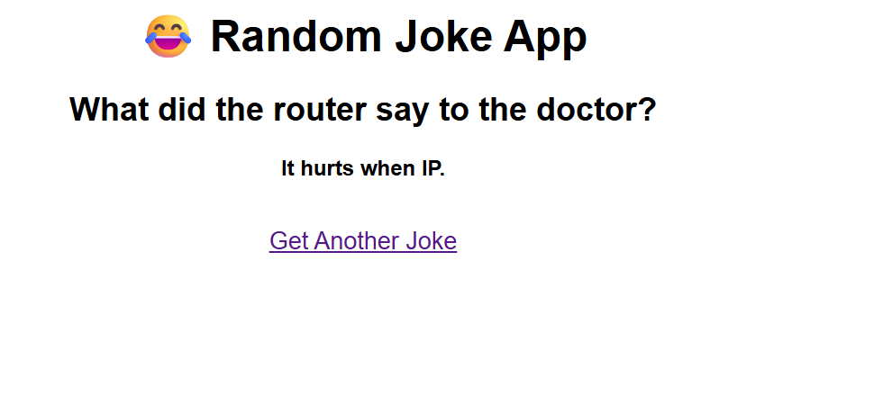

# Explanation

This Python script builds a small Flask web app that fetches and displays a random joke.  
  
1. **Import Libraries**:  
 - `Flask`: Used to create the web server.  
 - `render_template`: Loads and renders an HTML file from the `templates` folder.  
 - `requests`: Allows the app to send HTTP requests to an external API.  
  
2. **Initialize Flask App**:  
 - `app = Flask(__name__)` creates a new Flask web app.  
  
3. **Route Setup**:  
 - `@app.route('/')` defines the homepage URL route.  
 - The function `home()` will run when the homepage is accessed.  
  
4. **Fetch a Random Joke**:  
 - `requests.get(...)` sends a GET request to a free joke API.  
 - `joke = response.json()` converts the response to a Python dictionary.  
  
5. **Render Template**:  
 - Uses `render_template` to pass the joke's setup and punchline to an HTML template (`index.html`).  
  
6. **Start the App**:  
 - `app.run(debug=True)` runs the app and enables debugging for development purposes.  
  
Make sure you have an `index.html` file inside a `templates/` folder for this to work.